# **Network Redundancy**

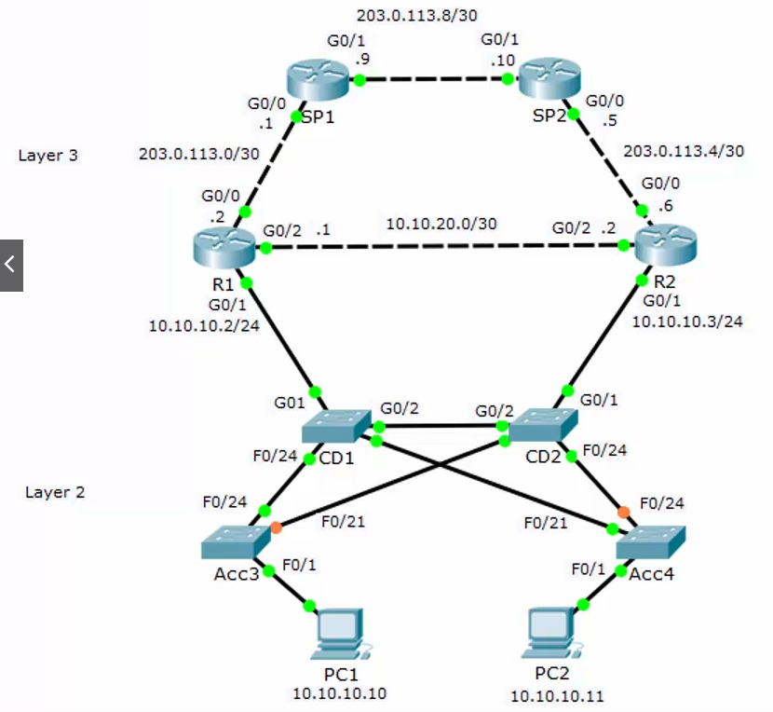

* The point of redundancy is to eliminate single points of failure
* Now we have added redundant switches, routers and Internet connections
* We can still reach the Internet if any core/distribution layer switch, router or link fails
* We do not typically implement redundancy at the **access layer** because end hosts have only one network card
* Servers with redundant NICs are an exception
* Redundancy and failover are relatively easy to implement for Layer 3 routing
* Routes on R1:

Static route to SP1:

*ip route 0.0.0.0 0.0.0.0 203.0.113.1*

Backup default static route via R2 if link to SP1 goes down(5 is AD):

*ip route 0.0.0.0 0.0.0.0 10.10.20.2 5*

Backup route to inside via R2 if link to CD1 goes down:

*ip route 10.10.10.0 255.255.255.0 10.10.20.2*

# **Host Gateways FHRP**

* We have redundant gateways for the PCs in the 10.10.10.0/24 network:
  + R1 with IP address 10.10.10.2
  + R2 with IP address 10.10.10.3
* We could configure half our PCs to use 10.10.10.2 as their default gateway, and half to use 10.10.10.3
* That would be inconvenient and would require manual reconfiguration on the PCs

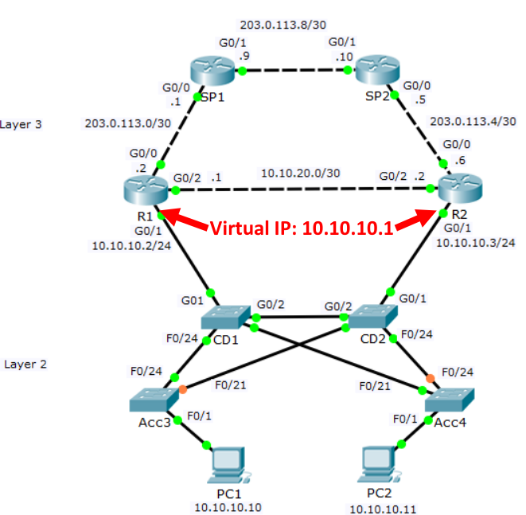

**First Hop Redundancy Protocols (FHRP)**

* First Hop Redundancy Protocols (FHRP) use a Virtual IP (VIP) and MAC address to allow for automated gateway failover
* The hosts use the VIP as their default gateway address
* If a physical gateway fails, another gateway will take over

**Different FHRP protocols**

1. Hot Standby Router Protocol (**HSRP**): Cisco proprietary. Deployed in active/standby pair.
2. Virtual Router Redundancy Protocol (**VRRP**): Open standard. Deployed in active/standby pair. Very similar to HSRP.
3. Gateway Load Balancing Protocol (**GLBP**): Cisco proprietary. Supports active/active load balancing across multiple routers.

# **HSRP (Hot Standby Router Protocol)**

* Both routers have a normal physical IP address and MAC address on their HSRP interface. Unique addresses are used on both routers.
* They both also have the HSRP virtual IP and MAC address configured on the interface. The same addresses are used on both routers.
* When they come online, one is elected the HSRP active router, the other is the standby
* The active router owns the virtual IP and MAC address and responds to ARP requests
* All traffic for the VIP goes through the active router
* The routers send hello messages to each over their HSRP interface
* If the standby router stops receiving hellos from the active it will transition to be the active router
* It will take ownership of the virtual IP and MAC address and respond to ARP requests

HSRP Configuration

*R1(config)#interface g0/1*

*R1(config-if)#ip address 10.10.10.2 255.255.255.0*

*R1(config-if)#no shutdown*

*R1(config-if)#standby 1 ip 10.10.10.1*

*R1#show standby*

Priority and Pre-emption

* You can choose which router will be the active by setting priority on the routers
* The router with the higher priority will be preferred (default is 100)
* In the event of a tie the highest IP address wins
* If pre-emption is also enabled, when a higher priority router comes back online after a failure it will transition back to active
* If pre-emption is not enabled (default), the lower priority router will remain active when the failed router comes back online
* This can be more stable if a higher priority router is flapping

*R1(config)#interface g0/1*

*R1(config-if)#ip address 10.10.10.2 255.255.255.0*

*R1(config-if)#no shutdown*

*R1(config-if)#standby 1 ip 10.10.10.1*

*R1(config-if)#standby 1 priority 110*

*R1(config-if)#standby 1 preempt*

*R2(config)#interface g0/1*

*R2(config-if)#ip address 10.10.10.3 255.255.255.0*

*R2(config-if)#no shutdown*

*R2(config-if)#standby 1 ip 10.10.10.1*

*R2(config-if)#standby 1 priority 90*

HSRP Version

* HSRP version 2 introduced a few minor improvements
* The default is version 1
* Both routers must be running the same version

*R1(config)#interface g0/1*

*R1(config-if)#ip address 10.10.10.2 255.255.255.0*

*R1(config-if)#no shutdown*

*R1(config-if)#standby 1 ip 10.10.10.1*

*R1(config-if)#standby version 2*

*R1#show standby*

**Active/Active’ HSRP**

10.10.10.0 Subnet

*R1(config)#interface g0/1*

*R1(config-if)#ip address 10.10.10.2 255.255.255.0*

*R1(config-if)#no shutdown*

*R1(config-if)#standby 1 ip 10.10.10.1*

*R1(config-if)#standby 1 priority 110*

*R1(config-if)#standby 1 preempt*

*R2(config)#interface g0/1*

*R2(config-if)#ip address 10.10.10.3 255.255.255.0*

*R2(config-if)#no shutdown*

*R2(config-if)#standby 1 ip 10.10.10.1*

*R2(config-if)#standby 1 priority 90*

10.10.20.0 Subnet

*R1(config)#interface g0/2*

*R1(config-if)#ip address 10.10.20.2 255.255.255.0*

*R1(config-if)#no shutdown*

*R1(config-if)#standby 1 ip 10.10.20.1*

*R1(config-if)#standby 1 priority 90*

*R2(config)#interface g0/2*

*R2(config-if)#ip address 10.10.20.3 255.255.255.0*

*R2(config-if)#no shutdown*

*R2(config-if)#standby 1 ip 10.10.20.1*

*R2(config-if)#standby 1 priority 110*

*R2(config-if)#standby 1 preempt*